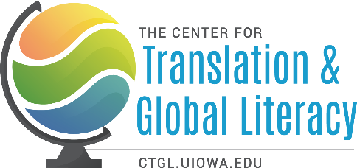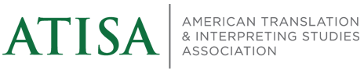

2026 SUMMER INSTITUTE ON TRANSLATION ACROSS THE CURRICULUM
UNIVERSITY OF IOWA, IOWA CITY / June 17-21, 2026
“THE UNDERGRADUATE CURRICULUM: PROGRAMS, COURSES, ACTIVITIES”
In an era of rapid globalization, the need to promote translation as a crucial global literacy skill is widely recognized. At the same time, many fear that teaching translation can be used to bypass the study of foreign languages, and to promote cultural stereotypes and the hegemony of English as a lingua franca. Teaching translation literacy, however, addresses these fears by keeping issues of language front and center in a variety of pedagogical contexts, offering opportunities for students of foreign languages to apply their knowledge while motivating others to study foreign languages.
The 2026 CTGL-ATISA Summer Institute invites those constituencies in higher education that are in a position to promote translation as a global literacy skill, and that want to incorporate translation into their teaching (e.g., instructors of World Languages and Literatures, Comparative Literature, and Creative Writing and General Education). The Summer Institute is open to faculty and graduate students at all stages of their career, and administrators.
This four-day residential gathering features a combination of lectures, roundtables, syllabus design workshops, discussion sessions and individual tutorials for those interested in
- theoretical approaches to translation as an asset-building pedagogy
- designing and implementing translation-related activities, courses, tracks, or programs
- exploring careers in the language industry and providing concrete training for students
- fostering a greater understanding of the asymmetries among world languages through comparative grammar and comparative stylistics.
- teaching translation and interpreting in the age of AI
- round Table on curricular strategies strategies to support world language education

The Summer Institute is co-directed by Brian James Baer, Professor of Russian and Translation Studies, Kent State University, Founding Editor, Translation and Interpreting Studies, and Aron Aji, Director of Translation Programs, The University of Iowa. The 2026 Institute Faculty will be announced at a later date..
The Summer Institute is made possible through funding by the US-DOE NRC grant and by ATISA.
Out of town participants will be provided hotel lodging, breakfast and lunch vouchers at local eateries, and catered dinners on Wednesday and Saturday evenings. Participants are responsible for travel to and from Iowa City. A limited number of travel subsidies are available upon request.
For more information, please visit www.ctgl.uiowa.edu.

2026 SUMMER INSTITUTE ON TRANSLATION ACROSS THE CURRICULUM
“THE UNDERGRADUATE CURRICULUM: PROGRAMS, COURSES, ACTIVITIES”
UNIVERSITY OF IOWA, IOWA CITY / May 31-June 4, 2026
APPLICATION FORM
Application Deadline: JANUARY 25, 2026
Date: _______________________________________________________________________
Name: _______________________________ Email: _________________________________
Affiliation (academic Unit and Institution): _________________________________________
Title / Position: _______________________________________________________________
Please check all that apply:
- I have taught translation courses.
- My academic unit is interested in developing translation-focused courses.
- My academic unit is interested in developing a minor or track in translation.
- My academic unit or college is interested in developing a BA or BS in Translation.
- I am interested in using translation pedagogy and practice in Foreign Language courses.
- I am interested in using translation pedagogy and practice in World Literature & Culture courses.
- I am interested in teaching translation workshops for undergraduates.
Please explain in a paragraph of 150-250 words you would like to undertake during the 2026 Summer Institute. Send this along with a current CV to ctgl-connect@uiowa.edu with the subject heading: Application: 2026 Summer Institute.

