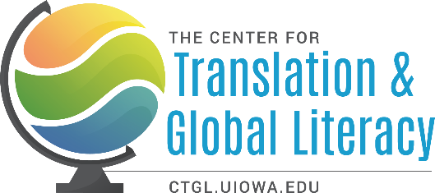

GUIDELINES FOR UNDERGRADUATE TRANSLATION PROGRAMS

Preamble
  - The ongoing need for translators who are prepared to work in multilingual, multicultural, multidisciplinary settings;
  - emergence of new translation technologies, and concomitant urgency to train human translators who have the critical perspective, interpersonal skills, and cultural experience necessary for translation;
  - the rise of interest in undergraduate courses on translating and interpreting, emergence of translation tracks or minors in various depts, creation of translation majors at colleges and universities across the US.

Summary of Process
The University of Iowa’s Center for Translation and Global Literacy (US-DOE funded NRC) invited 15 directors and coordinators of translation programs at US institutions to a virtual SUMMIT (Feb 2025) with the aim to collaborate and draft a document that can support and guide the ongoing efforts to develop robust curriculum, degree tracks, certificate programs, majors and minors focused on undergraduate level translation education and training.

Purpose of this document
    - Recognize translation studies to be a varied community of learning practices and foci and enthusiastically promote the generative interchange between its subfields and related fields.
    - Advocate for undergraduate translation programs that enable students to leverage language / cultural knowledge / lived experience/ professional experience in their multiple forms and expressions.
    - Develop shared goals for translation in the undergraduate curriculum.

Guidelines (meant to be descriptive, not prescriptive)
- General goals/learning objectives for undergraduate programs
- Multiple literacies gained through translation

General goals for undergraduate programs
  - Students will learn diverse theories and practices of translation, and develop a working understanding of shared terminology, concepts and ethics in the field of Translation Studies.
  - Through their own practice of translation, students will expand their capacities in language learning, writing, reading, and public speaking in their working languages, including home languages.
  - Students will have an opportunity to explore various domains in translation including literary translation, applied translation, different modes and genres of interpreting, computer-assisted translation, community translation, and audio-visual translation.

  - Students will have an opportunity to engage in real-world activities, such as capstone projects, internships, collaborative translation, and networking with professional translators.
  - Students will be exposed to relevant translation tools and acquire technology-based learning skills in order to adapt to changing technologies in the profession (such as AI), and reflect on the critical implications of these technologies.
  - Students will learn how to situate language and translation in the wider context of the humanities, and in productive relationship with the social sciences and STEM fields.
  - Students will become aware of translation as a mode of cultural communication and recognize the role of translation in navigating culture, politics, literature, the arts, and industry.
  - Students will develop a self-reflexive understanding of the significant role of translators as ethical agents and mediators in modern human relations, political organization, and world systems.

Multiple Literacies Gained through Translation

- Translation Literacy
  - Language(s) proficiency(ies) for Translation and Interpreting
  - Translation Theory
  - Translation Approaches and Strategies
  - Quality Assessment for Translation and Interpreting
  - Research skills for Translation and Interpreting
  - Technology skills
  - Knowledge of tools (MT, AI, CAT, etc.)

- Professional Literacy
  - Project Management
  - Technology skills
  - Use of tools (MT, AI, CAT, etc.)
  - Remote Interpreting Equipment
  - AVT tools
  - Self-care (e.g. Vicarious Trauma training for interpreters, ergonomics)
  - Professional pathways
  - Professional Associations (also Continuous Education)

- Ethical Literacy
  - Translation/Interpreting Ethics
  - Professional Ethics
  - Technology Ethics

- Global Literacy
  - Awareness of Linguistic Resources
  - Context
- History
- Culture
- Literature
- Professional fields (Legal, Medical, Technical)

